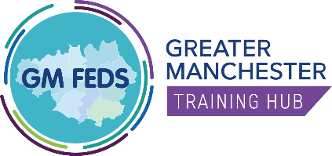
Greater Manchester NHSE GP Fellowship Programme
Information for GP Fellows

The GP Fellowship is a 2-year programme of support aimed at welcoming GPs into General Practice and their PCN

Eligibility | What you can expect | What not to expect | Benefits to you
- Working in a salaried or partner position within Greater Manchester  - Within two years of your CCT | - 1 paid CPD session (4hr 10 mins) per week  - Personal & professional growth  - Podcasts & Masterclasses  - Mentorship & Coaching  - Peer-support & networking  - Leadership training  - Portfolio-working opportunities  - Help building appraisal portfolio | - Lots of additional work  - Formal assessments and essays  - A fixed time per week | - Flexible programme of development  - Access to a PCN Portfolio opportunity  - Peer Support and Networking  - Leadership skills and Quality improvement training  - Support from a qualified Mentor

How to apply

Applications available on our website https://www.gmthub.co.uk/primary-care/gp-fellowship
If you have any questions please contact us at wbccg.GMTH@nhs.net

Who are we?

Greater Manchester Training Hub  The GM Training Hub is designed to meet the educational needs of the multi-disciplinary primary care team. We support primary care around workforce and retention including developing effective learning environments to increase student placements. | GP Program Lead –  Dr Mary Cheshire  Mary qualified in March 2020 and is a GP in Rochdale. Mary is able to offer her experience to ensure the Fellowship meets the needs of newly qualified GPs. | Project Administrator at GMTH –  Rob Harris  The first point of contact for your queries, Rob is there to ensure the smooth planning and execution of the Fellowship.

